“The Cup Challenge”—GATE Group--January

For our GATE Group session this month, I wanted our students to work on collaboration and team perseverance, so I started our time together with a short video from the movie, “Apollo 13.” The students watched the scenes when the NASA engineers and astronauts were asked to build an air filter device in which they needed “to fit a square peg into a round hole.”
The scene links are below, if you would like to see them. I feel that this was one of the most amazing parts of the movie, and more importantly, of our history!!
Square peg into a round hole-Apollo 13 clips
https://www.youtube.com/watch?v=C2YZnTL596Q
https://www.youtube.com/watch?v=Zm5nUEG5Bjo
https://www.youtube.com/watch?v=ze1hmt4_wPg
After watching the clips, I challenged our GATE students to a smaller task, but still one that would need collaboration as a team, and perseverance!
The “Cup Challenge” was on!
- I gave each group of 4 students a bag with 4 pieces of yarn, a rubberband, and 6 plastic drinking cups inside.
- Then the team had to place 3 cups upside down, with one cup right side up, on top of the previously placed cups.
- The team challenge was to create a device (using the rubberband and 4 pieces of string) that would allow all 4 team members to help pick up the cups and stack them into a pyramid with 3 on the bottom, then 2, and the 1 on top.
This is what it looked like at the start of the challenge, if the students figured out their device.
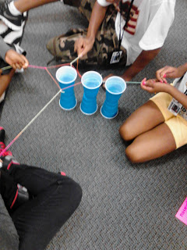
If the team was able to conquer the first challenge, then the group was given more cups
and asked to make a pyramid with a 4-3-2-1 configuration.

It was great fun watching this “challenge” in action, and I know the students had a great
time being a team and persevering.

To conclude our session, we discussed what the students learned about working together, persevering and about the ability of people to be able to conquer challenges together.
The astronauts and engineers from Apollo 13 definitely showed us that all things are possible if we believe, work hard and never give up!

